Start by going to https://rcmembers.sportngin.com/register/form/493797638
And create an account clicking the “sign up” link top let as highlighted below.

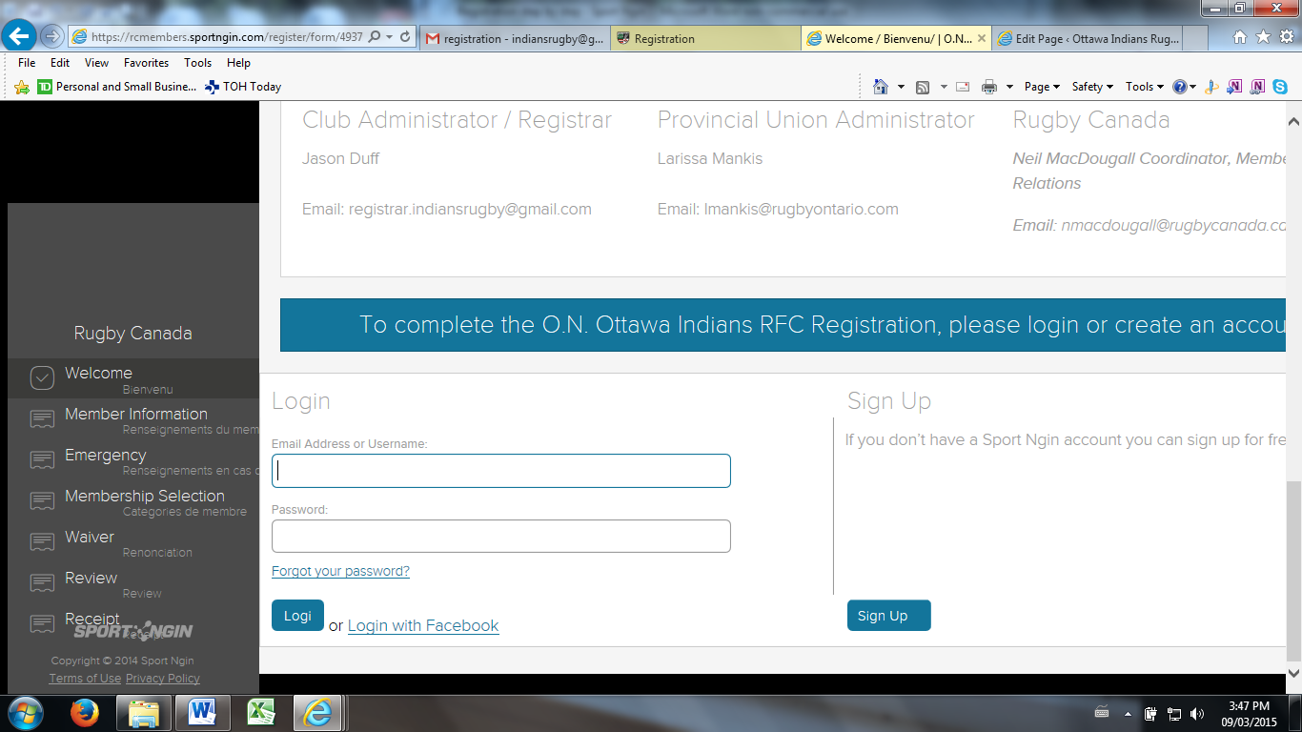

This page will come up. Fill in all pertinent information and click the “sign up for your sport ngin account” at the bottom of the page.
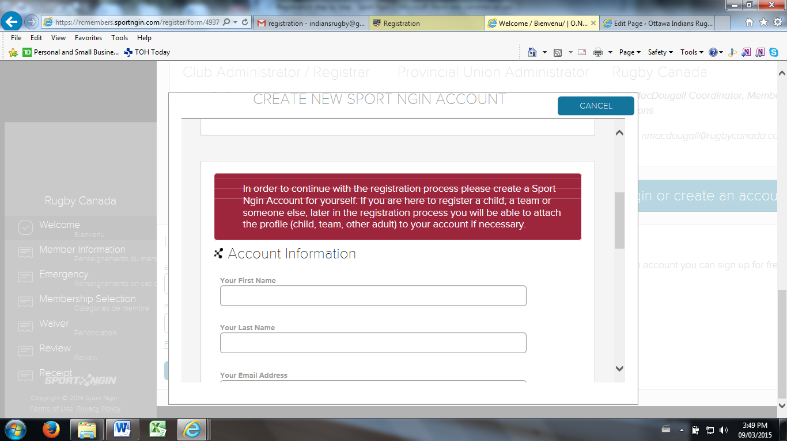

The following message will pop up prompting you to your email address which sends an account activation email, with the following instructions: Click on the confirmation link within the email to activate your new account.
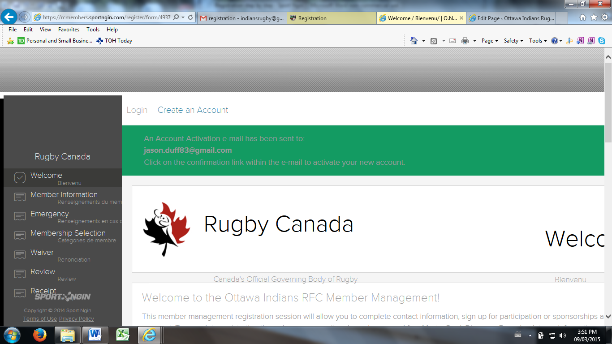

The following is the message you will recive:
Action Required: Account Activation for Rugby Canada Memberships
Hi John,
Welcome, and thank you for creating an account on the Rugby Canada Memberships website.
To confirm your email address and activate your account, please click on the following link or paste the URL into your browser: <note from registrar: click this link>
https://login.sportngin.com/account/activate/c37f9cddfd50d6238c70ea1f7826a905ebcefe3da442a4849e3dbefc57071078?set_site_id=6917&next_url=http://www.rugbycanada.ca.prod.sportngin.com
Your Username is: *******
You have 72 hours to activate your account before it will be removed from our system.
Thank You,
Rugby Canada Memberships
http://www.rugbycanada.ca.prod.sportngin.com
Powered by Sport Ngin
http://www.sportngin.com

Clicking on the noted activation link will bring you to this page – at which point you can start to register. Note the user name will be in the top left signifying that you are signed in (hidden here in this picture).

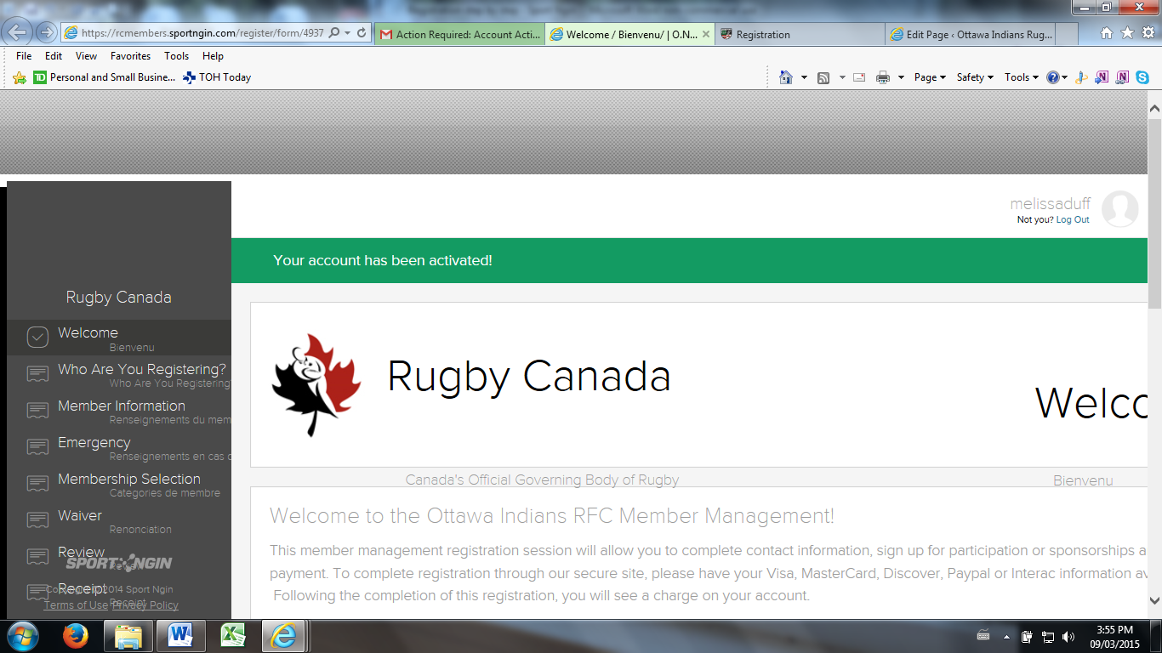

To continue with registration scroll to the bottom of the page and select continue

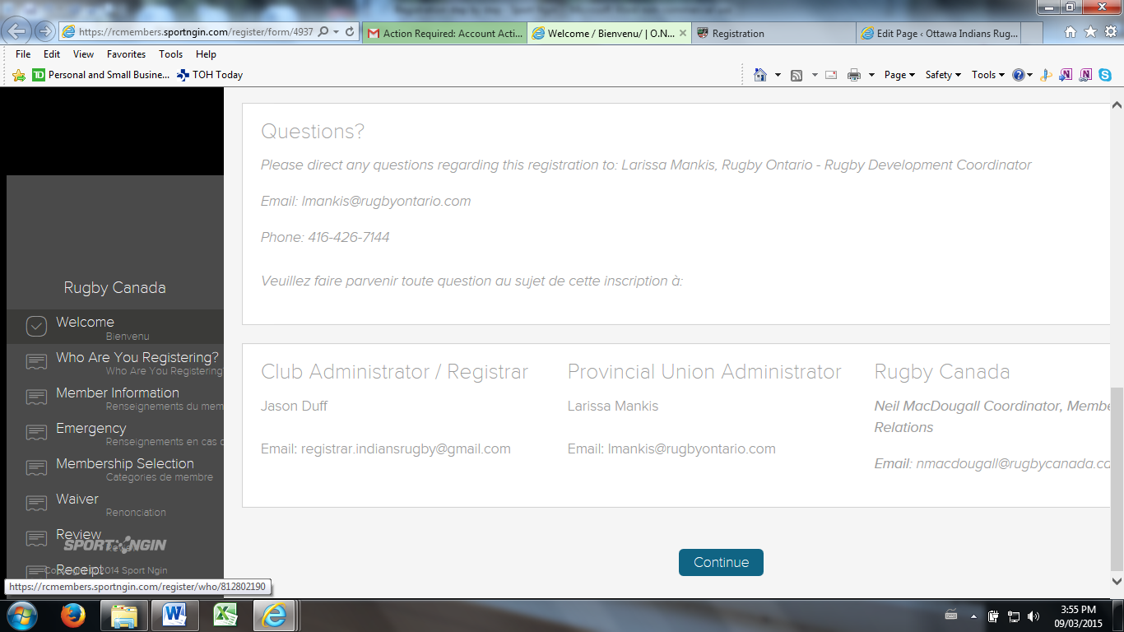

Note the progress bar shows you are on the second step. Here if this is your first time registering through the Sport Ngin system you will chose “a new person”. If you are returning to the system (example next year: season 2016) you can simply chose the name of the member who is shown – in this case it is the account for the registrar. This way you will not have to re-input the member’s information each time they register through the Sport Ngin system – only the first time.

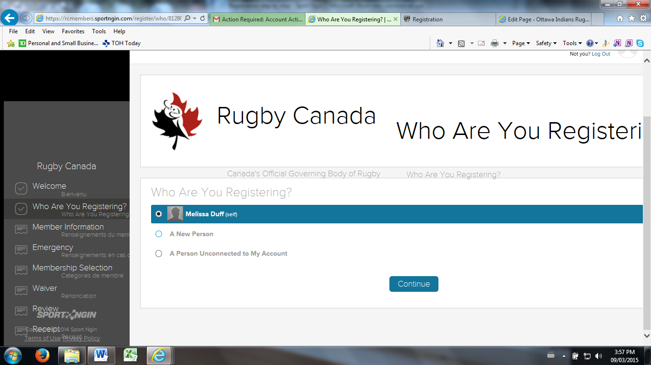

The “new person” selection will request the to be members name. On the following page enter all the required information. And click continue at the very bottom of the page. Notes on next page.

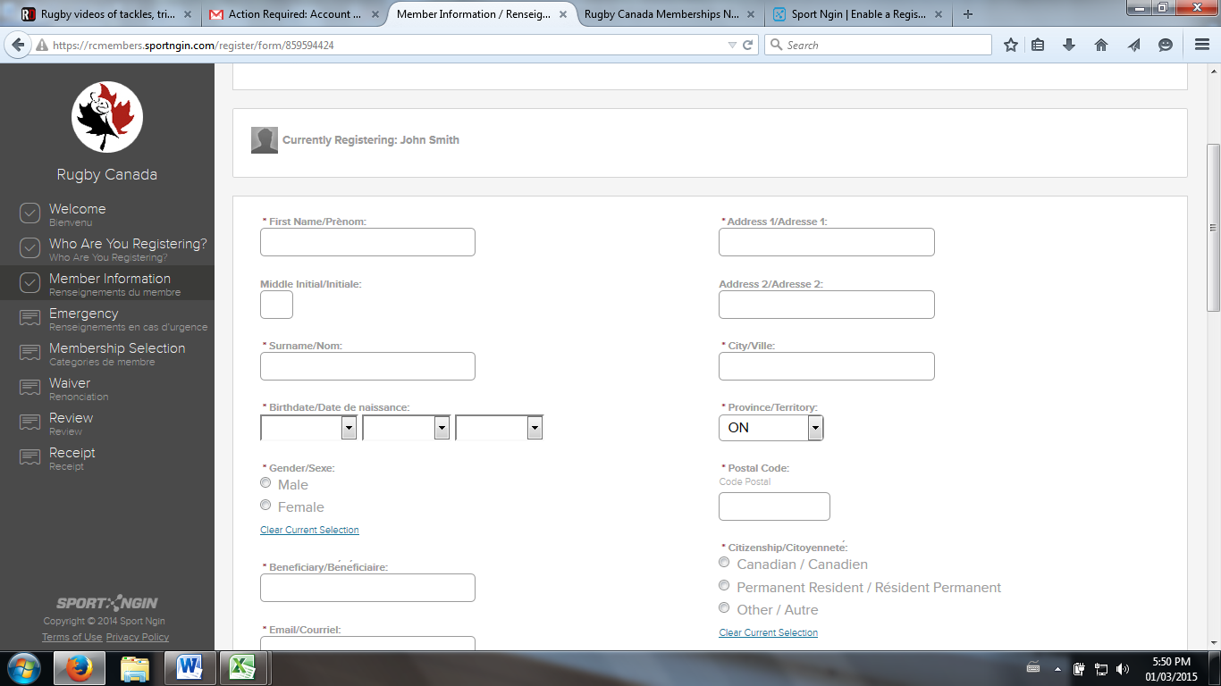
Email address: input the email address of the beneficiary (normally the parent) som options are displayed to decide how the beneficiary is to receive any correspondence from the system.

All * boxes are mandatory

The section regarding “Is this the first time you're registering this season?” this is for each individual member not the parent who may be registering 2-3 children at a time. Normally click yes.
Clicking continue will get you to the following page. Fill in the required info signified by the *. Note parents if the age put in the members info section indicates that the person is a youth/junior player a “Parents page” will open up prior to the emergency contact page . Click continue.
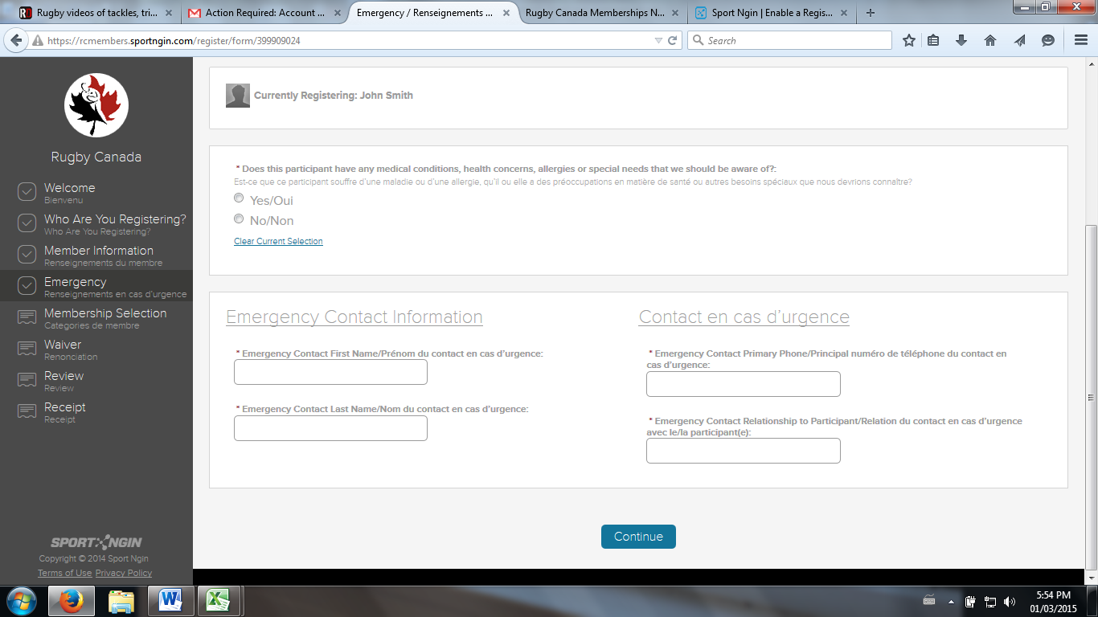

The next page reveals a number of different categories for membership. Note that most members will simply click “Athlete”.
For those members that are volunteering as Coaches, Board Members, or just volunteers click the category that best describes your role(s) in the club. Note ALL COACHES and BOARD MEMBERS MUST Register themselves for liability purposes. Board members who are also players SHALL register under that category.
If you register for more than one category (ex. Player and coach) you should only be charged for the category with the highest cost, you shouldn’t be charged the insurance as a player and also as a coach.

All coaches, referees, volunteers and board members SHALL be reimbursed their insurance fee for that category only. Example: If you are a player and a Referee the club will reimburse the amount of referee fees only. Any other questions can be sent to the club registrar at: registrar.indiansrugby@gmail.com

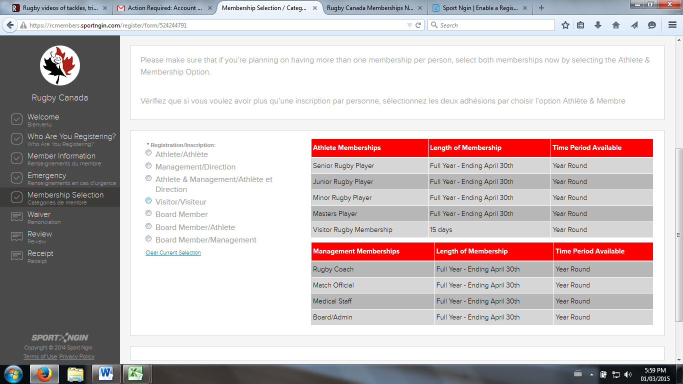

Once you chose a selection – Athlete for the vast majority. There will be a selection possible for different specific playing categories based on the person’s age. For instance a player born in 1962 will have the option for Masters/Old Boys rugby or Senior Players. You MUST register in the category that the member will be playing in primarily.
Once the specific selection is made, a selection pops up with the Rugby Canada Fees. Select this button and continue: example below:

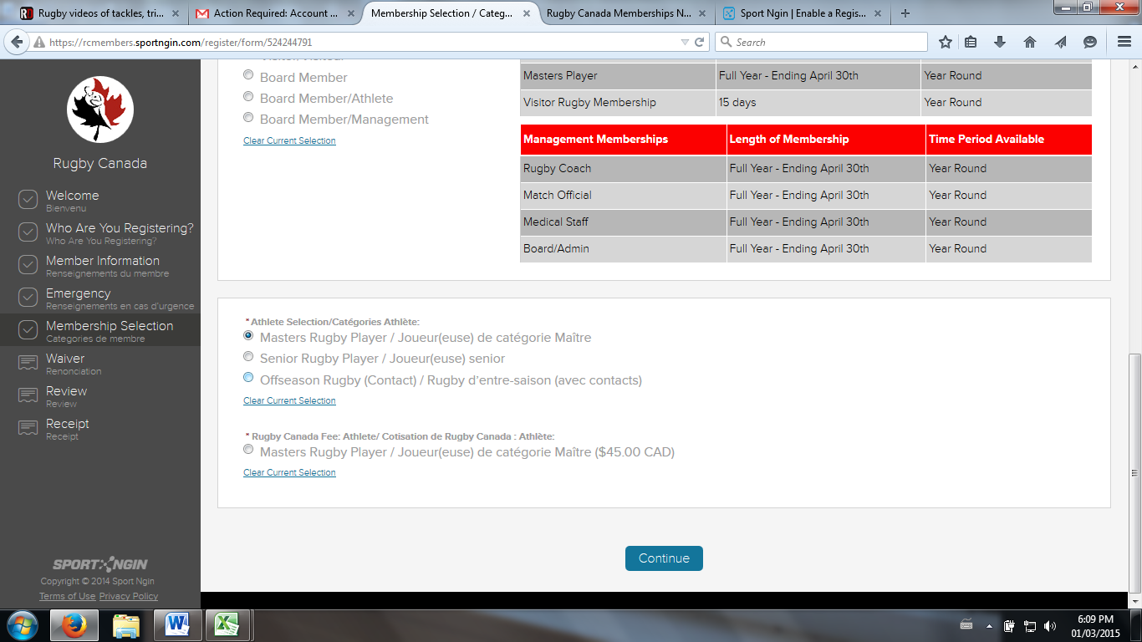

*Note U14’s are considered “Juniors” by Rugby Canada and Rugby Ontario – for the time being we classify U14’s as being part of the Ottawa Indians RFC Mini’s Program.
The next page is the selection for the provincial fee, select and hit continue.

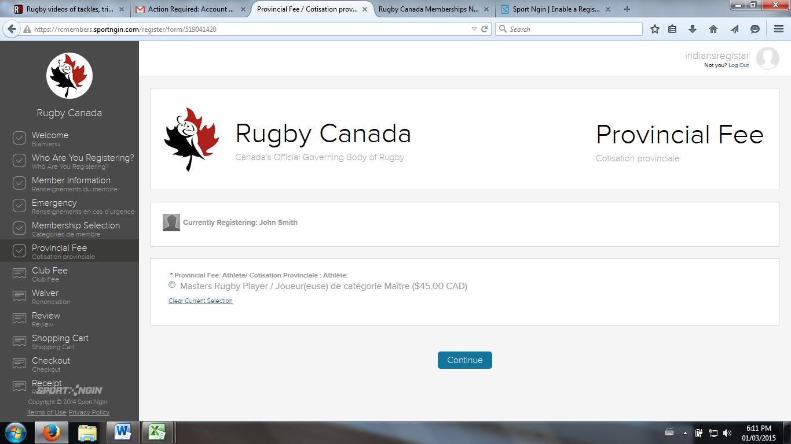

And finally the club fee

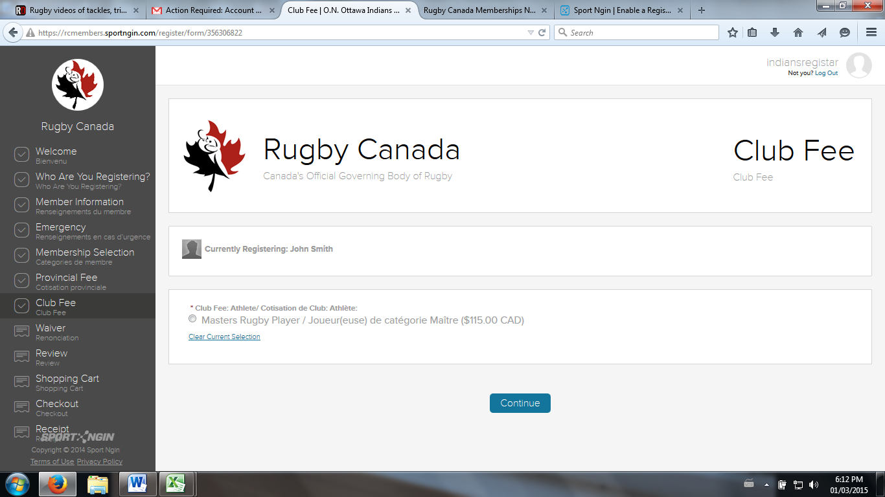

The member or Parent must read the waiver page and agree. The sections highlighted below are important. For the first section it means that any requests for refund MUST be sent to the registrar at registrar.indiansrugby@gmail.com. At which point the club executive will evaluate the request based on our internal refund policy noted at the link in the second section. Once the club approves the president will request the refund through to the province, cc’ing the member (or parent) the registrar and the treasurer. Once it is sent to the provincial bodies they will do what is required to approve and process the registration.

To get past this page click that you accept the terms of registration. There are two of them and sign by typing your name in the box provided. The opt in selection area is to “opt-in” for promotional rugby Canada emails and newsletters. It is up to the member to decide if they want these items or not.

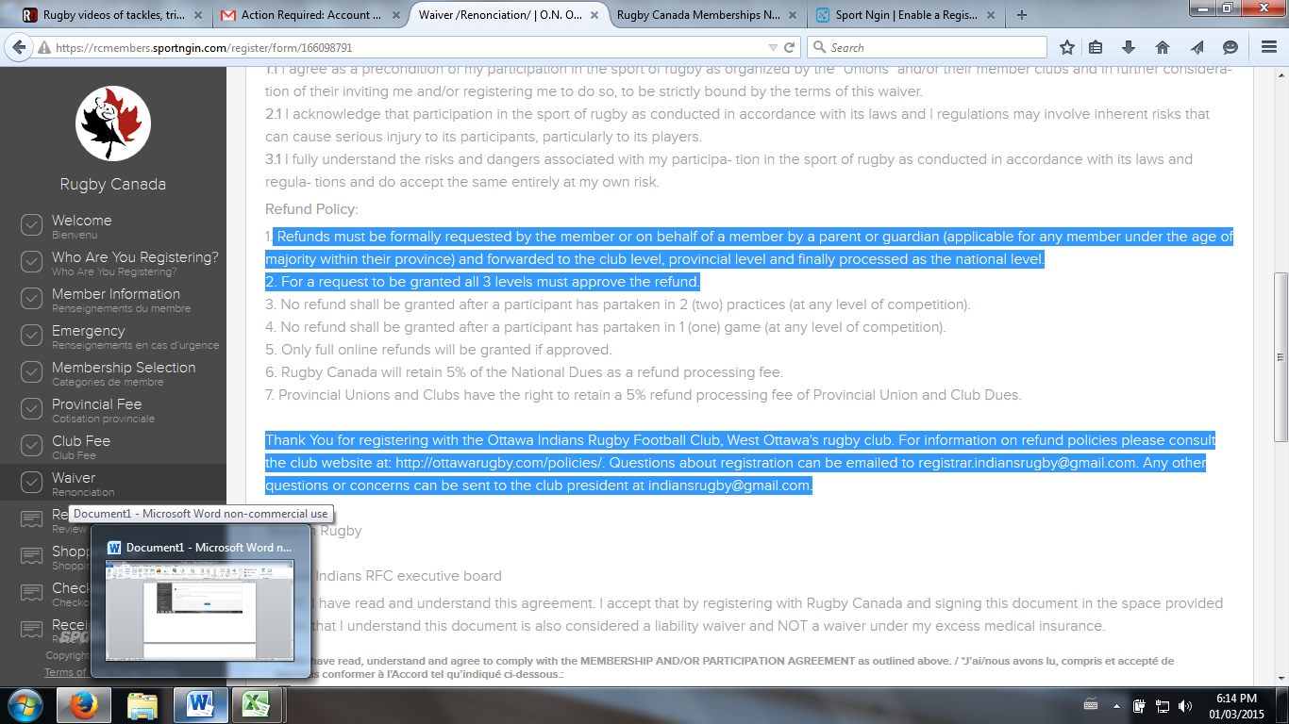

Upon clicking continue the user is brought to the review page for the individual being registered (themselves or their child). Please review this information for errors. If an error is noticed you can go back to that section by clicking the related area in the progress bar on the left or by clicking “edit” above each section on the review sheet. If there are no errors proceed to the shopping cart and checkout for payment and finalization.

The system accepts all forms of payments (Visa, Mastercard etc.) and you will receive an email as confirmation of registration.

***For Parents and those registering more than one person at a time:
At the bottom of the page there is the option to go right to the “shopping cart” to pay or register another person in the current registration session. Parents registering multiple children can use this option to create member/player profiles for all their children before registering for the upcoming season. When registering more than one member at a time, each time you come to the “review” page the members information will be presented, INCLUDING, the previous member information already entered.
For example at the review page a parent registering three children would:
- review the information for the first child, Click register another person;
- Enter the information for the second child up to the review page, ensure that the information for the first child is still present and the information for the second child is accurate, click “Register another person”;
- Do the same for the third child, ensuring all information for all three children are present and accurate and then go to the shopping cart in which case all the financial information for the invoice for registration is presented.

